**Name : Nabeeha Ali Rana**

**Section : DS-3A**

**Roll no : BSDSM - 037**

**AI Lab**

**Lab Task 6**

## **1. BFS without Queue**

* **How it works:**
  + The graph is stored as a dictionary where keys are nodes and values are their neighbors.
  + A list frontier keeps track of the current level of nodes.
  + Move to the next level by replacing frontier with next_frontier.
  + Continue until no nodes are left.
* **Why it works:**
  + BFS explores level by level (all neighbors first, then their neighbors).
  + Using frontier simulates the queue behavior without explicitly using one.
* **Output:**

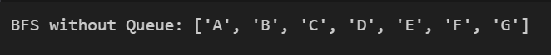

## **2. BFS with Queue (Node Class)**

* **How it works:**
  + Each node is represented as a Node object with a value and a list of neighbors.
  + A queue (deque) is initialized with the start node.
  + Continue until the queue is empty.

* **Why it works:**
  + A queue ensures First In, First Out (FIFO) order → guaranteeing BFS traversal.
  + Object-oriented representation (Node class) makes the graph easier to extend.
* **Output:**

